Education in the later Roman Empire by (Naka & Marrou, 2025)
in education in

Education in classical cultures
Also known as: instruction
Written by

,

•All
Fact-checked by

Last Updated: Jul 15, 2025 • Article History

News •
Republicans press leaders of Georgetown, Berkeley and CUNY on antisemitism complaints • July 15, 2025, 5:34 PM ET (AP)
The dominant fact is the extraordinary continuity of the methods of Roman education throughout such a long succession of centuries. Whatever the profound transformations in the Roman world politically, economically, and socially, the same educational institutions, the same pedagogical methods, the same curricula were perpetuated without great change for 1,000 years in Greek and six or seven centuries in Roman territory. At most, a few nuances of change need be noted. There was a measure of increasing intervention by the central government, but this was primarily to remind the municipalities of their educational duties, to fix the remuneration of teachers, and to supervise their selection. Only higher education received direct attention: in 425 ce, Theodosius II created an institute of higher education in the new capital of Constantinople and endowed it with 31 chairs for the teaching of letters, rhetoric (both Greek and Latin), philosophy, and law. Another innovation was that the exuberant growth of the bureaucratic apparatus under the later empire favoured the rise of one branch of technical education, that of stenography.
The only evolution of any notable extent involves the use of Greek and Latin. There had never been more than a few Greeks who learned Latin, even though the growing machinery of administration and the increasing clientele drawn to the law schools of Beirut and Constantinople tended to increase the numerical size of this tiny minority. On the other hand, in Latin territory, late antiquity exhibited a general recession in the use of Greek. Although the ideal remained unchanged and high culture always proposed to be bilingual, most people generally knew Greek less and less well. This retrogression need not be interpreted solely as a phenomenon of decadence: it had also a positive aspect, being an effect of the development of Latin culture itself. The richness and worth of the Latin classics explain why the youth of the West had less time than formerly to devote to the study of the Greek authors. Virgil and Cicero had replaced Homer and Demosthenes, just as in modern Europe the ancient languages have retreated before the progress of the national languages and literatures. Hence, in the later empire there appeared specialists in intercultural relations and translations from Greek into Latin. In the 4th and particularly in the 5th century, medical education in Latin became possible, thanks to the appearance of a whole medical (and veterinary) literature consisting essentially of translations of Greek manuals. It was the same with philosophy: resuming Cicero’s enterprise at a distance of more than five centuries, Boethius (c. 480–524) in his turn sought with his manuals and his translations to make the study of that discipline available in Latin. Although the misfortunes of Italy in the 6th century—including the Lombardian invasion—did not permit this hope to be realized, the work of Boethius later nourished the medieval renaissance of philosophic thought.
Nothing better demonstrates the prestige and the allure of Classical culture than the attitude taken toward it by the Christians. This new religion could have organized an original system of education analogous to that of the rabbinical school—that is, one in which children learned through study of the Holy Scriptures—but it did not do so. Usually, Christians were content to have both their special religious education provided by the church and the family and their Classical instruction received in the schools and shared with the pagans. Thus, they maintained the tradition of the empire after it had become Christian. Certainly, in their view, the education dispensed by these schools must have presented many dangers, inasmuch as Classical culture was bound up with its pagan past (at the beginning of the 3rd century the profession of schoolteacher was among those that disqualified one from baptism); but the utility of Classical culture was so evident that they considered it necessary to send their children to these same schools in which they barred themselves from teaching. From Tertullian to St. Basil the Great of Caesarea, Christian scholars were ever mindful of the dangers presented by the study of the classics, the idolatry and immorality that they promoted; nevertheless, they sought to show how the Christian could make good use of them.
With the passage of time and the general conversion of Roman society and particularly of its ruling class, Christianity, overcoming its reserve, completely assimilated and took over Classical education. In the 4th century Christians were occupying teaching positions at all levels—from schoolmasters and grammarians to the highest chairs of eloquence. In his treatise De doctrina Christiana (426), St. Augustine formulated the theory of this new Christian culture: being a religion of the Book, Christianity required a certain level of literacy and literary understanding; the explication of the Bible required the methods of the grammarian; preaching a new field of action required rhetoric; theology required the equipment of philosophy. The synthesis of Christianity and Classical education had become so intimate that, when the “barbarian” invasions swept away the traditional school along with many other imperial and Roman institutions, the church, needing a literary culture for the education of its clergy, kept alive the cultural tradition that Rome had received from the Hellenistic world.

Education in Ancient Rome by (United Nations of Roma Victrix, 2025)

Ancient Roman Education
Of the many cultural and technological advantages that ancient Rome held over its competitors, the education of its citizens is not one that immediately comes to mind.
However, there can be no doubt that the Roman education system resulted in citizens, politicians, and generals who were all better equipped to meet challenges and solve problems than those in many other ancient societies.
For example, the literacy rate in ancient Rome was astronomically higher than surrounding areas outside of Roman influence, which has an incalculable effect on labor efficiency.
By the time of the Imperial Period, they had developed a system of formalized education that would not only continue to enrich their own citizens, but formed the basis for the Western educational systems that are in use today.

Education in the Early Republic
In the first days of the Roman Republic, Roman family life was dominated by the practice of patria potestas, whereby the father was wholly and completely responsible for the upbringing of each of his children, including education.
In theory, the father would teach each of his children directly or assign a family member to do it, should he be unable or unwilling to do it himself. In practice, however, there was no real social expectation that children actually be educated at all. The one exception was if a person was seeking to enter political life, in which case everyone expected them to be thoroughly educated.
This decentralized institution where a father is left to educate children himself, or simply decide not to do so, obviously had the effect of providing very different education levels for different children. A lot of the time this had to do with wealth and social class, but there were plenty of examples of rich fathers who saw no use in educating their children, and poor fathers who thought that education was their children’s best chance of a better life.
One unexpected aspect of this uneven educational approach was that girls from wealthy families were often educated alongside their male siblings. While ancient Rome would always be male-dominated, this access to education would carve out a sphere of independence for Roman women that was seen in very few other places in the ancient world.

Education in the Late Republic and Imperial Period
In the 3rd century BC, Rome would begin to conquer Greek areas of the Italian peninsula and then engage Carthage in the First Punic War. Both of these events had the effect of heavily exposing Rome to Greek culture and influence on a large scale for the very first time.
Countless Greek artisans and craftsmen were displaced to Roman lands following their conquest. Many Romans were immediately taken with certain Greek activities and practices, some of which were hundreds of years old by this time.
One of these was the practice of public education by professional tutors and in academies, along with the accompanying social expectation that all children receive some form of formal education (a Greek idea that remains popular worldwide to this day).
With the Hellenization of Rome came the very first Greek tutors. These men were often slaves gained in the spoils of war and were placed in the wealthiest and most prominent Roman families to help educate their children in the Greek fashion.
Since the Greeks had a long tradition of literature, Greek tutors were able to use these texts to teach the children the same lessons and themes year after year. Before this, Roman society was unable to develop this same literary educational method on their own because they did not have their own tradition of literature.
Alongside simple arithmetic, reading, and writing, complex Greek subjects such as philosophy, logic, ethics, poetry, astronomy, geometry, and political science entered the Roman world for the first time. However, Roman society saw the fields of music and athletics, which were very important to the Greeks, as unworthy of study.
At the same time, the ancient Roman institution of patria potestas was deteriorating in social importance. This meant that the social convention where a father was completely responsible for the upbringing of his own children was not as extreme as in prior centuries. The result was that Roman leaders began to think of the education of Rome’s youth as a matter of state importance rather than confined to the private family sphere.
Following the Greek example, many of these leaders saw that a formal system of schools and academies with a consistent curriculum was the best way to create educated Roman citizens, which would only serve to strengthen the Republic.
Before long, Rome had a great number of these academies with tiered courses of study, where advancement was more dependent on ability rather than age. Furthermore, education became expected, though never mandatory, for all male children.

Gender & Education
While Roman society developed a rather sophisticated and modern system of education, participation was almost completely limited to male children. The education system was quite accessible to boys, even those who were from the lower social classes, but girls were not admitted except in very extreme circumstances.
This meant that the study of certain topics, particularly those surrounding politics and war, were completely closed to female students.
Even though the formal school system was not accessible to girls, there was still a robust tradition of educating young women in Rome. This practice would continue in the old, pre-Greek method, where a girl’s education would be handled by her family or close friends.
In some cases, a family could even hire a private tutor to educate their daughter, resulting in an education that might even be better than the one publicly available to boys.
As such, women in the upper echelons of Roman society were often highly educated and politically savvy.
The topics of a woman’s education would vary from those given to men because of the different roles that women had to play in society. Girls were given lessons that would help them efficiently run a household as adults. This would include traditional domestic tasks like home maintenance and food preparation, but also included what we would call financial and business training, like investment and labor management.
This is because women were traditionally responsible for the family estate while men were otherwise occupied outside of the home. Women in Rome also maintained independent financial assets after marriage, which necessitated some of this training.
Click here to find out more about women in ancient Rome.

Tiers of Education

Early Childhood & Moral Education
From the earliest days of the Roman Republic, children’s education began with their parents teaching them the basics about moral conduct and discipline. This included learning not only right from wrong, but also understanding one’s roles and responsibilities as a member of a greater society. This pietas, or sense of societal duty, was different for boys and girls.
For boys, the greatest sense of devotion was to the state, while girls were taught that duty to one’s family, particularly their father and/or husband, was paramount. This practice of moral education in early childhood by family members persisted even after the adoption of formal schools.

Ludus
The first primary school that young boys attended at or around age six was called a ludus literarius, where they would be given instruction by a teacher whose job it was to do so. The focus of this stage of education was the essential skills for functioning in Roman society, such as reading, writing, basic arithmetic, and measurements.
Instead of dedicated buildings, Roman public policy allowed for creative uses of space to accommodate these ludus schools. Some of them were rotated between empty warehouses that were not currently in use, or even held in the middle of a public street.
There were no examinations or formal grades given, but a student’s performance was either praised or corrected by the instructor, creating hierarchy and competition among them.
The time a boy would spend being instructed in a ludus school varied based on their proficiency levels. In fact, boys from wealthy families often skipped this stage altogether because their parents could afford a tutor for private instruction.
If a student showed promising ability, and his family possessed the requisite funds, he could move on to the next level of education.
Related Page: Gladiator Training Schools (Ludi)

Grammaticus
Between the ages of nine and twelve, gifted Roman boys from esteemed families would go to study with a grammaticus. Grammatici were teachers with more training, who would hone the skills that the students had learned in the earlier ludus school.
Students would examine poetry, literature, and the Greek language in greater depth to master those topics. They would also be given lessons in public speaking, which was an important skill among Roman elites.
These grammatici teachers were paid on a per-pupil basis and the most renowned of them became wealthy and respected members of Roman society.

Rhetor
At age fourteen or fifteen, the most gifted students would graduate from their grammaticus and go to study with another level of teacher called a rhetor. This was the final stage of the formal Roman education system, and very few boys would ever reach it.
Instruction at this level was focused on public speaking and further mastery of Latin and Greek meant to prepare students for careers as politicians or lawyers. There was a formal distinction drawn between training in language designed to advise or persuade, compared to training that was meant to understand complex texts, as in law or religion.
Additionally, there was training given in other abstract subjects, like geometry and mythology. This was designed to "flesh out" and provide a more rounded education for a student, instead of focusing purely on topics that would be needed for their chosen career path. This is similar to elective courses in modern-day universities.

Philosophy
A final level of education in Roman times that warrants a mention is the field of philosophy. In the ancient Roman and Greek worlds, philosophy was concerned with inquiry into the unexplained or abstract in a very practical sense. It often dealt with astronomical or natural observations that could be called rudimentary science.
Only the greatest Roman minds were concerned with philosophical topics. They strove to drive the enterprise of collective human knowledge forward, in much the same way that modern academics and scientists do today.

Education in Ancient Rome
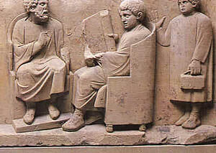Education in Rome, Stone Carving
Education was seen as very important within Ancient Rome. Rich people especially put a lot of faith into education and schooling. The poor did not have the opportunity to receive a formal education though they often still learnt to read and write. Children within rich families were well schooled and taught by a private tutor or went out to school. Schools equivalent to today were usually only for boys.
Learning in public schools was heavily disciplined, with caning for the slightest mistake. This was to encourage the belief that boys would learn more quickly and accurately if they were in constant fear of making mistakes. For pupils who continually got things wrong, they were held down by two slaves and beaten by the tutor with a leather whip.
"The teacher must decide how to deal with his pupil. Some boys are lazy, unless forced to work; others do not like being controlled; some will respond to fear but others are paralysed by it. Give me a boy who is encouraged by praise, delighted by success and ready to weep over failure. Such a boy must be encouraged by appeals to his ambitions."
Quintilian, a teacher in the 1st Century AD.
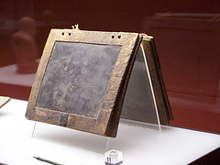Wax Tablet
There were not many subject choices in Rome, so children probably became bored quite quickly. The days were also much longer than modern day schools, beginning from sunrise with a short lunch break during the day, then arriving home by sunset. Lessons were learned off by heart and without question - the children only needed to know facts to escape beatings. Books were too expensive so lessons were generally dictated to the class.
Ancient Rome had two types of schools - one for children up to 11 or 12 who learned reading, writing and basic mathematics using an abacus. Older children would attend more advanced schools, studying specific topics such as public speaking and writings of the great Roman intellects. Girls did not usually attend these schools as they were able to get married from age 12, where boys waited until 14.
Girls were only allowed to learn reading and writing while boys received lessons in honourability and physical training to prepare them for a man’s role in society. Girls from rich families received a home education to learn how to be a good wife and run a good household, with tasks such as music, sewing and the running of a kitchen.
A school week was seven days instead of five, with no weekend. However there were many school religious holidays, along with market days which meant school closure, and even a summer holiday.

Roman Education
3Save

Article

by Laura K.C. McCormack
published on 24 April 2023
Available in other languages: French, Spanish
Subscribe to topic Subscribe to author Print Article PDF
Roman education had its first 'primary schools' in the 3rd century BCE, but they were not compulsory and depended entirely on tuition fees. There were no official schools in Rome, nor were there buildings used specifically for the purpose. Wealthy families employed private tutors to teach their children at home, while less well-off children were taught in groups.
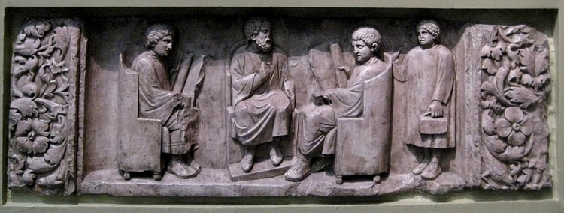
Roman School
Shakko (CC BY-SA)

Schools
Teaching conditions for teachers could differ greatly. A tutor who taught in a wealthy family did so in comfort and with facilities; some of these tutors could have been brought to Rome as slaves having been captured during war times, and they may have been highly educated. Other teachers, employed by the less well-off rented a room to hold classes or set up a school in the extended area of a shop, which the Roman historian, Suetonius (69 to c. 130/140 CE) refers to as a pergula (Gram.18.1). It was not uncommon for poorer teachers to hold classes for their students in outdoor public places – the trivium – the corner of the street, or in the piazzas. Classes began at dawn and continued until noon. The Roman poet, Martial (38/41-103 CE), complained about being woken at dawn by the booming voice of a teacher and his outdoor class: "Before the crested rooster has crowed you shatter the silence with your harsh words..." (Ep. 9.68).
Schools were privately operated by teachers & therefore dependent on tuition fees.
Schools were privately operated by teachers and therefore dependent on tuition fees. Teachers were of relatively low status, and throughout antiquity, the profession was seen as a humble one. Schoolteaching was seen as a trade, in the servile commercial sense, and it paid poorly.
Parents paid the school fees in instalments at the end of each term, however, this was not a certainty; they did not always pay due to not having the money to do so, or because they were unhappy with the progress of their child, and as a result, teachers often found themselves in difficult financial positions. In the education hierarchy, the litterator (primary teacher), who required no special qualifications, was on the lowest level of income. In 301 CE, the salary for a primary teacher was 50 denarii a month per pupil; a bushel (c. 35 l) of wheat was 30 denarii. The grammaticus, a more prestigious position as an advanced educator is recorded in 301 CE as receiving a salary of 200 denarii per pupil per month. The rhetor, the teacher of rhetoric, required greater skills and expertise, and as a result, there were opportunities for achieving a good salary.

Students
The educator and orator, Quintilian (35-96 CE) believed that school was preferable to home education as the child benefited from the social community of the school. Education for children began proper at seven years of age. Most pupils were boys, but girls did attend, especially at primary level; girls rarely advanced beyond the first level as they tended to be married in their early teens.
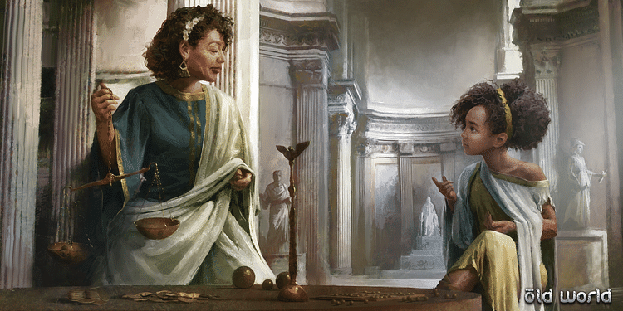
Ancient Private Tutor
Mohawk Games (Copyright)

The size of a school appears to have varied greatly. Martial in his Epigrams writes of Munna getting a third student (14. 223), however, Quintilian refers to a crowd (Quint. Inst. II. 32-4) in the grammar and rhetoric schools. The teacher sat in a large chair with his students sitting in a semicircle around him, or in rows before him. The usual seating for students in the classroom space was backless stools. School desks did not exist, and the student placed his tablet on his knees to work. A class may contain students of different ages and abilities, and they tended to work independently. The teacher did not teach his class as a whole; each student would come individually to him to receive instructions and to read out his completed lessons. Teachers had access to limited teaching materials, books were rare, and writing materials were expensive. They recited passages, which the students memorised for study purposes. Children learned to recite from memory poetry, grammatical treatises, and obscure words and their meanings.

Equipment
Students brought with them to their place of learning, waxed tablets and equipment which included a sponge for erasing, a knife for sharpening reed, and a ruler; these items were carried in a small case known as a theca. Those children who came from wealthier households may have had a slave accompany them to class. Papyrus was rarely used as it was expensive; where it was used it would have been in single sheets or broadsheets sewn together to make exercise books. More commonly, exercises were written on ostraca – broken pieces of pottery. Teachers also used large ostraca for writing out long passages or collections of moral maxims. Wooden tablets were also used, and some would come in notebook form. Tablets could have a surface coated in wax on which a sharp stylus made of metal, wood, or bone was used for writing, or the surface could be unwaxed on which pen and ink were used.
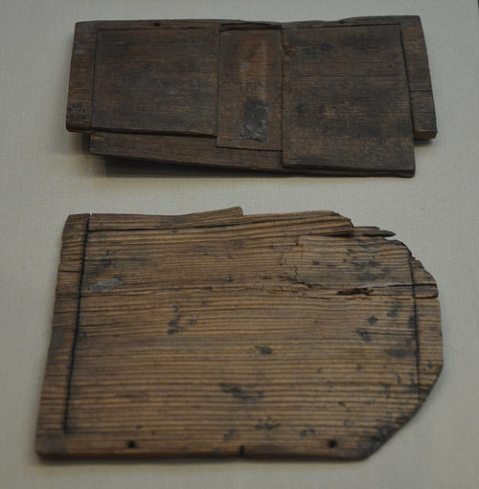
Wooden Writing-tablet
Carole Raddato (CC BY-SA)

Curriculum
There were three levels of education: the basic Three Rs was the first stage. The litterator was responsible for teaching the younger children. Lessons included teaching the child to form and write letters; the teacher carving the alphabet into a wooden board and then having the child trace the letters. The tablets used by children were usually small enough to fit in one hand, and as a consequence would not hold a lot of text. Students were able to write quite small letters, about one centimetre (0.39 inch) in height, and with practice this size reduced to 0.5 cm (0.19 inch). They learned the shapes and names of the letters, then the syllables, and finally the construction of words and sentences. Children also copied out sentences, which should not be useless but, according to Quintilian in his textbook Institutio Oratoria, should carry some moral lesson for the child so that "the impression made upon his unformed mind will contribute to the formation of his character" (1.1 31-34).
Ancient books were more difficult to read as most texts had no spaces between the words, no paragraphs, & no punctuation.
The skill of reading was somewhat harder to acquire than today. Ancient books were more difficult to read as most texts had no spaces between the words, no distinction between capital and lower-case letters, no paragraphs, and no punctuation. Arithmetic for the students began with counting on their fingers and with pebbles (calculi), and then they moved on to using an abacus. They also learned their addition and multiplication by chanting. Many children did not advance any further than this stage.
The second stage for students aged ten to eleven was study with the grammaticus; children moving onto this level would usually have come from the more affluent classes. Many of these children may have learned to read and write at home and then went directly to the grammaticus, who would develop and refine their writing and speaking and teach them Greek. Suetonius writes of a time when the grammaticus engaged in certain kinds of exercises suited to the training of orators, such as problems, addresses, paraphrases, and character sketches, so that they would not be handing their students to the rhetoricians wholly ignorant or unprepared. These students also learned music, philosophy, astronomy and natural science.
When they were given the toga of manhood, students who were sometimes as young as 15 years, could move onto the third stage, which would require a teacher of rhetoric. A rhetor trained students in public speaking, Roman law and politics, astronomy, geography, literature, philosophy, music, and mythology. Students would study with their rhetor until the age of 20 or even later. The rhetor was tasked with educating them to become skilful orators; they were given exercises to develop their skills, which included declamations, a rhetorical piece on an invented theme for political and forensic oratory. The declamation exercises tackled scenarios of familial or social disorder by reasserting the commonly held views of the Roman elite in the still impressionable minds of the young.
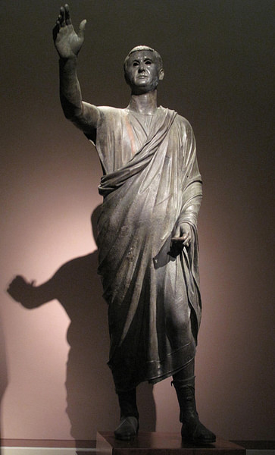
The Arringatore (Orator)
corneliagraco (CC BY)

Suetonius recalls his own school days when his rhetor would declaim and engage in discussion every alternative day, sometimes giving instruction in the morning and in the afternoon declaim. Students were given topics and asked to compose speeches. two categories of speech are referred to by Seneca the Elder (55 BCE to 39 CE) in his collection of declamations:
- suasoria – a fictitious speech in which the speaker gives advice to a historical or semi-historical character regarding the character's future conduct, intended to persuade someone to adopt a certain course of action.
- controversia – a fictitious speech in which one argued for one side of a point of law.
Quintilian's commentary paints us a picture of these young boys standing to give their speeches and being generously applauded and loudly praised by their fellow classmates without any regard for the quality of their fellow student's speech.

Discipline
As in any school environment, there were those times of distraction; Lucian recalls that he made little oxen and horse figures from the wax of his writing tablets (Dream 2). There were arguments amongst the children, and of course, the age-old tactics employed to avoid work; Persius describes how to blur his vision he "... would smear ointment on my eyes when I did not want to work on a speech" (Sat. 3. 44-47).
Although physical punishment was used by many teachers as a way of disciplining, some teachers employed different methods as incentives to stave off boredom and distraction; Suetonius writes of one teacher's method:
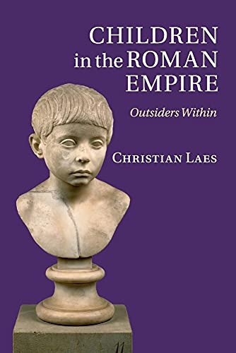
Book Recommendation
Children in the Roman Empire: Outsiders Within
by Laes, Christian
published by Cambridge University Press (2016)
$50.00

For to stimulate the efforts of his pupils, he used to pit those of the same advancement against one another, not only setting the subject on which they were to write, but also offering a prize for the victor to carry off. (Gram. 17.1)
These competitions, Suetonius notes, rewarded the successful student with the prize of an old book, valuable for its beauty and rareness.
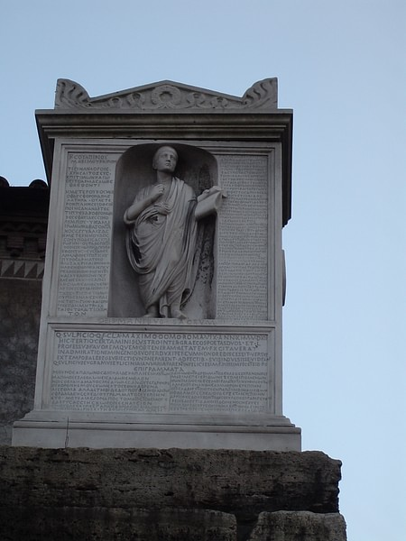
Quintius Sulpicius Maximus Memorial
Joris (Public Domain)

The importance of education was highlighted by educators like Quintilian, who wrote of the child being nourished, educated, and his inborn intellect being sharpened. Education was not made compulsory. Many would have remained illiterate. Those boys of the poorer classes, whose parents could afford to send them to school, did not go any further than primary education, having learned the practical skills that they required to be able to find employment. Girls, too, having had a basic education, could begin work at this early age. The child from the wealthier classes was afforded the luxury of a full education which prepared them for positions in upper-class society. It was not uncommon for some young men to continue their studies abroad in places like Athens, with Greek masters.

